1. Describe ‘default’ part of Calculate() function in cal.c

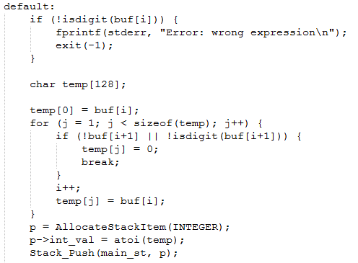

‘default’ part is code for **reading input buffer as integer** and **push it in to main_st stack.**

Why? We go to default when input character (buf[i]) is not ‘+’, ‘-‘, ‘*’, ‘/’, ‘^’, ‘(‘, ‘)’.

From first if clause, we eliminate the case of input character is not a digit.

We now read buffer as a string of digits and store it on temp.

Then we allocate p as integer type, and set value as the temp string integer.

We then push p into main_st, where we put all the operands.

1. Briefly summarize the Shunting-yard algorithm

**Shunting-yard algorithm**, invented by Edsger Dijkstra, is **a method to parse mathematical expressions specified in infix notation into a postfix notation string**, also known as Reverse Polish notation (RPN).

The detailed algorithm is noted below.

